# System Design (SDLC - Initial Version)

## User Roles:

* **Admin/Editor:** Adds summarized news posts with title, summary, source link, and tags.
* **User:** Reads summarized news and filters posts by tags or date.

## App Components & Layout:

1. **Header:** App name and navigation.
2. **News Feed (Homepage):** Displays summarized news posts.
3. **Filter Section:** Allows filtering by tags or date.
4. **Add News Page (For Admins):** Form to add new posts (Title, Summary, Source, Tags).
5. **Storage:** Uses LocalStorage to save and retrieve posts.

## Homepage (User View)

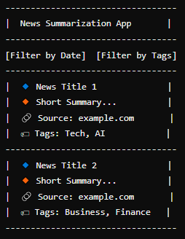

## Admin Page (Add News)

